Employee Data Analysis to Predict Salary
Based on Specific Factors
with Machine Learning Approach
Syafrial Fachri Pane^{#1}, Amri Yanuar^{#2}, Bachtiar Ramadhan^{#3}, Nur Tri Ramadhanti Adiningrum^{#4}
#Diploma IV/ Informatics Engineering Study Program, International Business Logistics University
Jl. Sariasih Number 54, Bandung 40501, West Java, Indonesia
1syafrial.fachri@ulbi.ac.id ²amriyanuar@ulbi.ac.id
³1204077_bachtiar@students.poltekpos.ac.id 41204061_nur@students.poltekpos.ac.id

Abstract— Providing an appropriate salary is one of the important factors to boost employee performance. Unfortunately, the current development of the company does not have a decision media to predict employee salaries based on data quality. In predicting, not many factors are taken into consideration, so this study aims to predict salaries based on specific factors. The study was conducted using a larger number of factors than other studies. The more factors considered to predict salary, the better the model will be. The factors taken include the independent factor in the form of Age, JobLevel, TotalWorkingYears, YearsAtCompany and the dependent factor in the form of MonthlyIncome. The data analysis technique used is multivariate linear regression analysis. The model successfully passed the test in the model validation step which resulted in an accuracy value of 90.9%. So it can be concluded that the model can perform well. Furthermore, this research produces data visualization using the Django framework.

Keywords— Salary Prediction, Multivariate Linear Regression, Specific Factors, Web Base

- INTRODUCTION
The development of science and technology in the era of the Industrial Revolution 4.0 is growing rapidly. The Industrial Revolution 4.0 itself began to occur through the form of intelligence engineering and also the internet of things as a driving framework and connectivity between humans and machines [1]. Thus, we get a combination of internet and digital technology with conventional industry, where it has the aim of significantly increasing efficiency, productivity and customer service [2]. This revolutionary era will disrupt various activities in various fields such as in the fields of technology, economy, social and politics [1]. Today, life is at the beginning of a revolution that is able to change the way we work, live, and communicate with one another[3].
Perubahan karakteristik pekerjaan adalah salah satu pengaruh tersendiri dari datangnya revolusi industri 4.0[4]. Perubahan karakteristik pekerjaan akan mencabut pekerjaan yang ada sebelumnya dan menggantikanya dengan karakteristik pekerjaan yang baru [5]. Karakteristik baru pada pekerjaan juga requires workers with new competencies [6]. Of course the company must be ready to compete with other companies [7]. Furthermore, companies need to have advantages and effective management to face the competition [7]. Thus, one aspect that has a major impact on the success and progress of a company is the performance of its employees [7]. Even though the company has sophisticated technology, but there is no manpower in it, the company will not be able to achieve its goals [7].
Therefore, determining the right wage or salary by the company for its employees is one of the factors that influence internally on the progress of a company. In addition, companies are also required to be willing to pay additional salaries for employees who have worked optimally and in accordance with what is needed by a company. Unfortunately, the current development of the company does not yet have a decision media to predict employee salaries based on data quality.
The characteristics of the dataset used to predict employee salaries consist of parameters based on specific factors. Furthermore, these factors will be tested for validity and correlation using a machine learning approach. These factors will be taken based on the correlation coefficient interpretation guidelines [8]. To determine the dominant factor in salary prediction, the correlation coefficient to be used is the level of moderate, strong, and very strong relationship. The method used in machine learning is regression. Regression is used to predict employee salaries. Of course, the results of employee salary predictions need to be visualized in real time to be used by companies in making decisions quickly. The visualization of the prediction results will be displayed based on a web base with the Django framework.

- LITERATURE REVIEW
- Machine Learning
Machine learning can be defined as an application on a computer in the form of a mathematical algorithm that is adopted with a learning model that is sourced from data and can issue predictions for the future [9].
- Multivariate Linear Regression
Multivariate linear regression is an extension of the simple linear regression model [10]. Multivariate linear regression model can be used to predict the relationship between one independent variable based on the value of two or more dependent variables [10]. Multiple linear regression also produces mathematical equations [10]. If there are more than two variables, then the type of linear relationship can be proven in the multivariate linear regression equation quoted in equation 1 and equation 2 as follows :

(1)
(2)
Information :
= Observed Values
= Regression Value
i = 1,2,3, k

In the equation above, there is one dependent variable, namely Y' and there are n independent variables, namely X₁, X₂,… X_{n} [10].

C. Scikit-Learn
Scikit-learn is a library in the python programming language that provides many types of machine learning algorithms. Scikit-learn uses a consistently oriented interface that makes it easy to compare methods. Scikit-learn integrates various machine learning algorithms for supervised learning and unsupervised learning[11].

D. Framework Django
Django is a web framework based on the Python programming language designed to build secure, feature-rich and dynamic web applications. This framework is always getting updates which makes the Django web framework the choice of many web application developers [12].

E. Previous Research
In previous research there are several journals that have been summarized as in table 1.
TABLE I
PREVIOUS RESEARCH

Research Area | Dataset | Method
Veterinarians Salary [13] | Veterinary survey data | Multiple Regression
Determinants of nutritionist job satisfaction [14] | Nutritionist questionnaire data | Multivariate Regression
Student salary prediction [15] | Higher education student data | OLS Regression
Annual salary prediction [16] | HealthEconomics.com global data | Multiple Regression
Contract analysis and highest salary [17] | Employment data | Logistic regression
Analysis of the competitive level of teacher salaries [18] | United States census data | Logarithmic Regressions
Teacher salary and talent analysis [19] | Schools and Staffing Survey Data (SASS) | Quantile Regression
Employee salary prediction [20] | Survey Google Form Data | Linear Regression
Determining employee salaries [21] | Employee contract and salary recap data | K-Means Clustering
Salary prediction with emotional intelligence [22] | Research survey data 785 subjects | Multivariate Linear Regression
Salary prediction after a certain year [23] | Employee data from the company | Linear Regression, Polynomial Linear Regression
Empirical analysis of house prices and salary predictions [24] | Dataset of employee salaries and house prices | Multiple Linear Regression
Salary prediction in the application of the regression model [25] | Salary data and length of work experience | Simple Linear Regression
Salary satisfaction analysis and prediction [26] | Staff employee data | Simple Regression
Salary increase prediction system design [27] | Enterprise Respurce Planning (ERP) Data | Linear regression, artificial neural networks, random forest regression
Salary prediction system to increase motivation [28] | Data of students who graduated with their salaries | K-NN, Naïve Bayes, Decision trees, Multilayer perception, SVM
Salary predictions in the IT job market [29] | Special e-Recruitment data for IT jobs | Logistic regression, KNN, Multi-layer perceptrons, SVM, Random forest, Vote, Vote3
HR salary predictive analysis [30] | Employment data | Logistic regression SVM
Prediction engine to predict salary [31] | Employment data | Decision tree classifier, Random forest classifier
Predictive analytics for alumni earnings [32] | Alumni study survey data | Quantile Regression, Quantile Random Forest, Quantile Gradient Boosting, Linear Regression, Random Forest Classifier, Gradient Boosting Classifier
Cloud computing biomedical digital signal facility [33] | Biomedical data | Framework Django
Diabetes prediction web app [34] | Diabetes clinical data | Framework Django
Deployment of lung disease classification [35] | Upper body x-ray dataset for Covid-19, Pneumonia and Normal | Framework Django

In this study, a descriptive qualitative method was used using a multivariate linear regression model with the Python programming language. Descriptive research is a research method used to gain the widest possible knowledge of the object of research. This descriptive study provides a detailed picture of a particular condition. Descriptive research aims to describe a situation as it is and interpret objects according to events, or anything related to variables that can be explained in the form of numbers or words..
In this study, the dataset used in the multivariate linear regression process is the staffing dataset sourced from Kaggle. The dataset used is employee_attrition_train.csv with 1029 rows and 35 columns, and employee_attrition_test.csv with 441 rows and 34 columns. The dataset can be accessed at the following link : https://www.kaggle.com/colearninglounge/employee- attrition

- METHODOLOGY

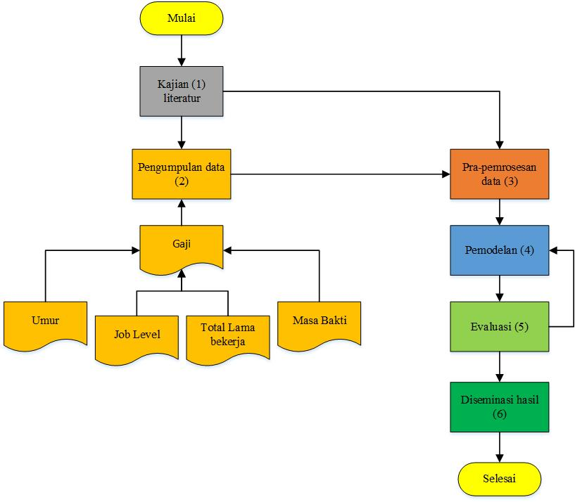
Figure 1. Methodology Flow

Based on the flow of the research methodology above, there are achievement indicators as follows.
TABLE II
EXPLANATION OF RESEARCH METHODOLOGY FLOWCHART
No. | Stages |  | Achievement Indicators
1. | Problem identification and formulation | → | - Mind map of salary prediction on specific factors based on data and on machine learning methods and the django framework.
2. | Literature Review | → | - Mind map of salary prediction on specific factors based on data and on machine learning methods and the django framework.
3. | Data collection | → | - Raw data from various factors (age, job level, length of work experience, length of service).
4. | Data pre-processing | → | - Pre-processed data that is ready for modeling with steps of cleaning, handling missing values and transforming.
5. | Modeling | → | - Multivariate Linear Regression Model is used to predict salary based on data from each specific factor.
6. | Evaluation | → | - Model performance.

- IMPLEMENTATION
The needs for making machine learning models and employee salary prediction applications are as follows:
- Software : XAMPP 3.2.4, Lucidchart, Visual Studio Code, Jupyter Notebook.
- Hardware : laptop merk LENOVO dengan kriteria : Prosesor IntelTM Core i3-4030U, RAM 4 GB, 64-bit OS. Software : Ms. Office, Windows 10 Pro.
- Machine Learning Model Implementation
  - Data Set
At the data set stage, the thing to do is understand and prepare the data. This stage can be referred to as Data Preprocessing. The method used in Data Preprocessing in this model is Data Cleaning. Here is the form of the data before it goes through Data Cleaning :
TABLE III
DATASET BEFORE CLEANING
 | Age | Attrition | … | YearsSince  LastPromotion | YearsWith  CurrManager
0 | 50,0 | No | … | 1 | 3
1 | 36,0 | No | … | 0 | 1
2 | 21,0 | Yes | … | 1 | 0
… | … | … | … | … | …
1027 | 29,0 | No | … | 0 | 3
1028 | 50,0 | No | … | 0 | 0
Because machine learning cannot read object data types, it is necessary to change the data type to integers. At this stage, the categorical encoder process is used.
TABLE IV
DATASET AFTER ENCODER
 | Age | Attrition | … | YearsSince  LastPromotion | YearsWith  CurrManager
0 | 50,0 | 0 | … | 1 | 3
1 | 36,0 | 0 | … | 0 | 1
2 | 21,0 | 1 | … | 1 | 0
… | … | … | … | … | …
1027 | 29,0 | 0 | … | 0 | 3
1028 | 50,0 | 0 | … | 0 | 0
In the dataset used, there are NaN/Null values. Therefore, the process of filling this value with the average value (mean) of the variables is carried out.
TABLE V
DATASET AFTER CLEANING
 | Age | Attrition | Business  Travel | Daily  Rate | …
0 | 50,0 | No | 2 | 1126,0 | …
1 | 36,0 | No | 2 | 216,0 | …
2 | 21,0 | Yes | 2 | 337,0 | …
… | … | … | … | … | …
1027 | 29,0 | No | 2 | 1378,0 | …
1028 | 50,0 | No | 2 | 264,0 | …
After all the data is in the form of an integer, check the correlation between the attributes to select the attribute that has a moderate-strong correlation with the salary attribute (MonthlyIncome).
TABLE VI
CORRELATION VALUE BETWEEN ATTRIBUTES
 | Age | JobLevel | Monthly  Income | TotalWorking  Years | YeasAt  Company
Age | 1,00 | 0,48 | 0,47 | 0,64 | 0,28
JobLevel | 0,48 | 1,00 | 0,95 | 0,78 | 0,54
Monthly  Income | 0,47 | 0,95 | 1,00 | 0,77 | 0,52
TotalWorking  Yeasrs | 0,64 | 0,78 | 0,77 | 1,00 | 0,62
YearsAt  Company | 0,28 | 0,54 | 0,52 | 0,62 | 1,00
Then, the next step is to drop attributes that have a correlation value under the medium-strong criteria and leave only the Age, JobLevel, TotalWorkingYears, YearsAtCompany attributes as independent variables and MonthlyIncome as dependent variables.
TABLE VII
DATASET AFTER DROP ATTRIBUTE
 | Age | JobLevel | Monthly  Income | TotalWorking  Years | YearsAt  Company
0 | 50,0 | 4 | 17399 | 32 | 5
1 | 36,0 | 2 | 4941 | 7 | 3
2 | 21,0 | 1 | 2679 | 1 | 1
… | … | … | … | … | …
1027 | 29,0 | 0 | 4025 | 10 | 4
1028 | 50,0 | 0 | 19331 | 27 | 1

  - Data Mining & Knowledge Process
At the stage of the Data Mining & Knowledge process, the process carried out is the selection of the type of method that is in accordance with the character of the data. This process is known as Modeling. In this model, the Data Mining Prediction process is used. The Data Mining & Knowledge process is carried out by comparing the effect of the dependent variable with reference to the correlation between each dependent variable and the independent variable. The implementation model used is Multivariate Linear Regression from the Scikit Learn module.
To create a machine learning model, the dependent and independent variables are first determined. Age, JobLevel, TotalWorkingYears, YearsAtCompany as independent variables and MonthlyIncome as dependent variables.
From the linear regression model, the independent coefficients are -5.054 for Age, 3871.7530 for JobLevel, 46.9405 for TotalWorkingYears, -9.8460 for YearsAtCompany and the dependent variable is -1728 for MonthlyIncome. The following is a linear equation quoted in equation 3 :

(3)

MonthlyIncome (Dependent variable)
Age (Independent variabel) JobLevel (Independent variable)
TotalWorkingYears (Independent variable)
= YearsAtCompany (Independent variable)

So it can be concluded that the multivariable linear regression equation quoted in equation 4 is as follows :

(4)

  - Data Evaluation
- Model Validation
Validation of machine learning models using OLS models and dmatrices. Here is a Summary of the OLS Model.
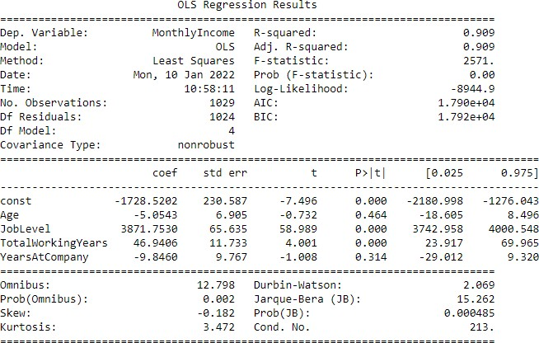
Figure 2. OLS Regression Result
- F-test (ANOVA)
The model feasibility test, also known as the F test, is a test carried out to determine whether the independent variables used in viewing the equation have a significant effect on the value of the dependent variable [36].
ANOVA test on multiple regression is used to see whether the model works better or not than the previous simpler model..
TABLE VIII
F-TEST OUTPUT (ANOVA)
F-Statistic | 2570,622889791836
Probability of Observing Value at Least as High as F-Statstics | 0,0000

The hypothesis obtained from the F test table is:
H0 = Independent variable simultaneously is not a significant explanatory to the dependent variable (model does not fit).
H1 = The independent variable is simultaneously significant explanatory to the dependent variable (model fits).

Based on table 8, it can be seen that Fs > P-value, which means that the hypothesis that can be taken is to accept H1 and reject H0. It can be said that the independent variables (Age, JobLevel, TotalWorkingYears, YearsAtCompany) and MonthlyIncome have a significant effect on demand. At the significance level of 5% (0.05), H0 is rejected because the probability value is 0.00, which means it is below 5%. So it can be concluded, the model used is suitable.

- T-test
The regression coefficient test or known as the t-test has the aim of testing the significant level of the independent variable constants found in the individual regression equations [36].
The existing hypothesis is :
H0 = There is no significant effect on the independent variable.
H1 = There is a significant effect on the independent variable.
α = 0,05 (Threshold)

Based on Figure 2, the t-test can be hypothesized as follows :
  - The value of the X₁ (Age) variable is above the significance level/acceptance of H₁.
  - The value of the variable X₂ (JobLevel) is below the level of significance/acceptance H₀.
  - The value of the variable X₃ (TotalWorkingYears) is below the level of significance/acceptance H₀.
  - The value of the variable X₄(Years Company) is above the significance level/acceptance H₁.

The conclusion is the independent variable (independent) JobLevel with the dependent variable (dependent) that is MonthlyIncome. While the independent variables Age and YearsAtCompany are variables that affect the dependent variable, namely MonthlyIncome.

- R-Square
R-square can be interpreted as a coefficient of determination. R-square shows the proportion of influence between the independent variable (independent) on the dependent variable (dependent)[37].
Based on Figure 10, the coefficient of determination (R-square) is 0.909 (90.9%). So, MonthlyIncome is influenced by Age and YearsAtCompany factors of 0.909 (90.9%). The residual value of the coefficient of determination of 0.091 (9.1%) is influenced by other unknown factors.

- Assumption Test
The following are various assumption tests carried out to see the validity of the model :
- Linearity
Linearity is a test used to determine whether the model used is a linear model or not [38]. This test is done by looking at the regression curve, which is the curve used to see the linear relationship between the independent variable and the dependent variable [38].
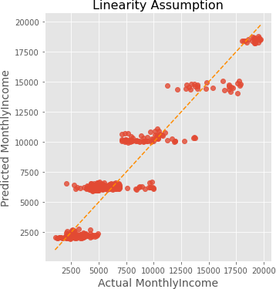
Figure 3. Linear Assumption Graph

In Figure 2, the scatter plot is spread around the diagonal line, so it can be assumed that there is a linear relationship between the independent (independent) and dependent (dependent) variables.

- Normality
Normality test is a test to see whether the existing variables are normally distributed or not [38]. The model is said to be good if the data is normally distributed or close to normal [38].

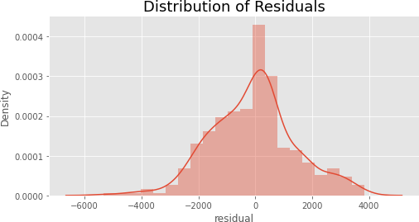
Figure 4. Residual Distribution Diagram

Based on the assumptions above, the following hypotheses can be seen :

H0 = Residuals are normally distributed.
H1 = Residuals are not normally distributed.

From the calculation results, it can be seen that the p-value calculated using the Anderson-Darling method is 0.00032261. This figure is below the specified threshold value of 0.05 which means that H0 is rejected and H1 is accepted. So that the assumption of normality is met.

- Multicollinearity
In multiple linear regression analysis, if there are two or more independent variables that are very strongly correlated, then there is multicollinearity [39].
This test is used to see the correlation between independent variables. To see whether there is multicollinearity or not, it takes criteria set through Variance Inflation Factors (VIF). If the VIF value is more than 10, then there is a problem with multicollinearity. The VIF value can be obtained by regressing the independent variables [40].
TABLE IX
VIF ATTRIBUTE VALUE

 | VIF | Variable
0 | 28,655370 | Intercept
1 | 1,690786 | Age
2 | 2,489052 | JobLevel
3 | 4,140803 | TotalWorkingYears
4 | 1,739893 | YearsAtCompany

Based on table 9, it can be seen that the values of the Age, JobLevel, TotalWorkingYears, and YearsAtCompany variables have a VIF value < 10 and by using a significance level of 0.05, it can be concluded that there is no multicollinearity in the predictor variables.

- Autocorrelation
Autocorrelation is a test that aims to test the model whether there is a relationship between the nuisance error in period t and the error in period t1. If a relationship is indicated, then the model experiences autocorrelation. A good model is a model that avoids autocorrelation [38].
In this step, the Durbin-Watson score is calculated using the durbin_watson() function from the created statsmodel, then scores with the following conditions :
- If the score is < 1.5 then there is a positive autocorrelation and the assumption is not fulfilled.
- If the score is between 1.5 – 2.5 then there is no autocorrelation and the assumption is satisfied.
- If the score > 2.5 then there is a negative autocorrelation and the assumption is not met.
Based on this study, the Durbin-Watson score was 2.160636. It can be assumed that there is little or no autocorrelation, which means the assumption is satisfied.

  - Homoscedasticity
Homoscedasticity is a test that aims to test whether the multivariate linear regression model has heteroscedasticity symptoms or not by looking at the presence or absence of a certain pattern on the scatterplot graph. The regression model can be said to be a good model if the model has homoscedasticity or does not occur heteroscedasticity[41].

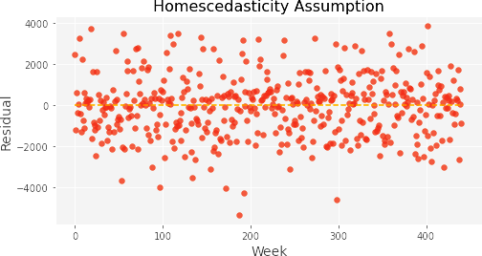

Figure 5. Residual Spread Plot
From the scatterplot graph (figure 5), it can be seen that the residual points spread randomly. The residual points are spread both above and below the zero point. Thus, it can be seen that the model used does not have heteroscedasticity symptoms.

- Application Interface Implementation
  - Salary Prediction Page
The display for the application to predict employee salaries is shown in Figure 6.

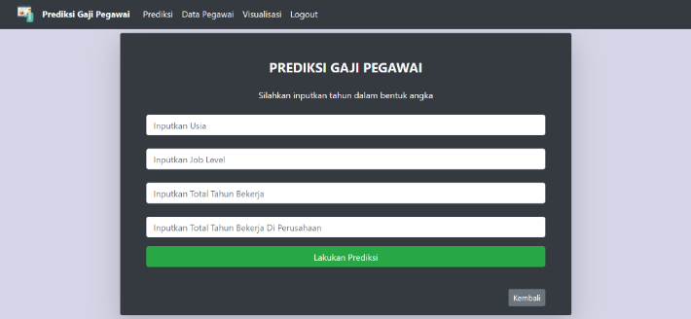
Figure 6. Salary Prediction Page

  - Salary prediction result page
The display for the application displays the results of employee salary predictions as shown in Figure 7.

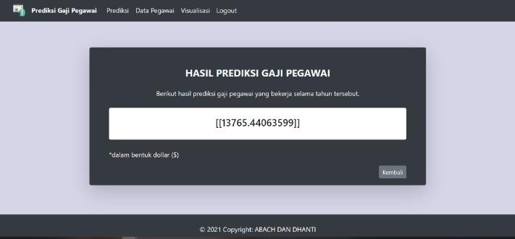
Figure 7. Salary Prediction Results Page

  - Employee data page
Application view to display employee data consisting of Id, Age, JobLevel, MonthlyIncome, and Action attributes. The employee data page is shown in Figure 8.
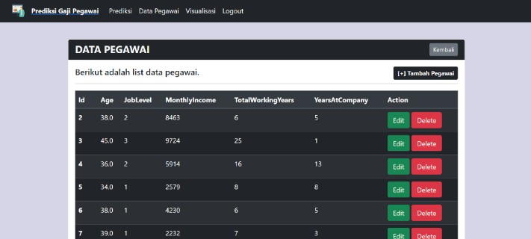
Figure 8. Employee Data Page

  - Add employee data page
Display application to input new employee data. The input form consists of Age, Job Level, Monthly Income, and Total Working Years, and Years At Company. The page for adding employee data is shown in Figure 9.

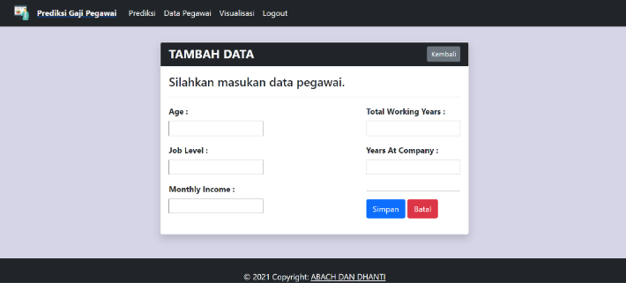
Figure 9. Add Employee Data Page

  - Employee data edit page
Display for the application to edit new employee data. The input form for editing data consists of Age, Job Level, Monthly Income, and Total Working Years, and Years At Company. The employee data edit page is shown in Figure 10.

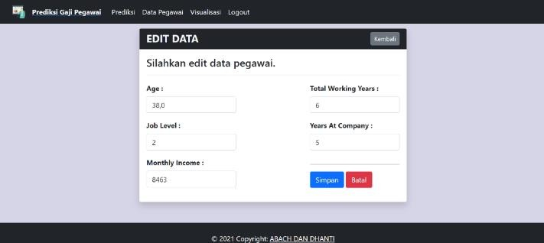
Figure 10. Employee Data Edit Page

  - Visualization page
Application view for visualization of the created model. The visualization page is shown in Figure 11.
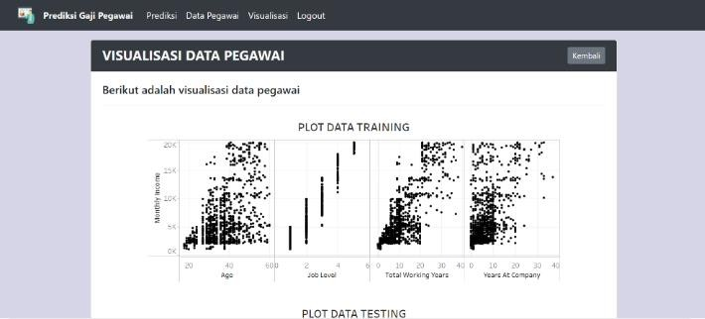
Figure 11. Visualization Page

- CONCLUSIONS AND SUGGESTIONS
- Concolusions
Based on the model taken from the OLS model, the accuracy value is 0.909. This accuracy is a good accuracy value, so it can be said that machine learning models can perform well for predicting salaries. The model designed using machine learning with this regression approach has successfully passed the model validation test, so it can be ascertained that the model created can predict employee salaries by using four independent variables, namely Age, JobLevel, TotalWorkingYears, and YearsAtCompany.
Based on the validity test, the accuracy value of 0.909 indicates that MonthlyIncome is influenced by independent factors (Age, YearsAtCompany) of 0.909 or 90.9%. The residual value of the accuracy is 0.091 or 9.1% which means MonthlyIncome is influenced by other unknown factors by 9.1%.
Data visualization from the results of the employee salary prediction model can be used as a form of web-based application using the Django framework. With this application, admins can predict employee salaries easily and quickly.

- Suggestions
Suggestions that can be submitted to researchers who will continue and develop this research are :
- The prediction model used can be more diverse to compare the performance of one model to another.
- The data source used is less than the maximum. In this study, only real items from Kaggle were obtained. It is hoped that in the future we can use real data directly from the company.

REFERENCES
[1] B. Prasetyo and U. Trisyanti, “Revolusi Industri 4.0 Dan Tantangan Perubahan Sosial,” Prosiding SEMATEKSOS 3, pp. 22–27, 2018, doi: 10.12962/j23546026.y2018i5.4417.
[2] H. Prasetyo and W. Sutopo, “Perkembangan Keilmuan Teknik Industri Menuju Era Industri 4.0,” 2017. doi: https://idec.ft.uns.ac.id/wp-content/uploads/2017/11/Prosiding2017_ID069.pdf.
[3] O. C. Pangaribuan and I. Irwansyah, “Media Cetak Indonesia di Era Revolusi Industri 4.0,” Jurnal Pewarta Indonesia, vol. 1, no. 2, pp. 134–145, Oct. 2019, doi: 10.25008/jpi.v1i2.11.
[4] A. A. Shahroom and N. Hussin, “Industrial Revolution 4.0 and Education,” International Journal of Academic Research in Business and Social Sciences, vol. 8, no. 9, pp. 314–319, Oct. 2018, doi: 10.6007/ijarbss/v8-i9/4593.
[5] S. Kergroach, “Industry 4.0: New challenges and opportunities for the labour market,” Foresight and STI Governance, vol. 11, no. 4, pp. 6–8, 2017, doi: 10.17323/2500-2597.2017.4.6.8.
[6] M. I. Manda and S. ben Dhaou, “Responding to the challenges and opportunities in the 4th industrial revolution in developing countries,” in PervasiveHealth: Pervasive Computing Technologies for Healthcare, 2019, vol. Part F148155, pp. 244–253. doi: 10.1145/3326365.3326398.
[7] Y. Adrianova Eka and Anyan, “Implementasi Model Regresi Linear Sederhana Untuk Prediksi Gaji Berdasarkan Pengalaman Lama Bekerja,” Journal Education and Technology, vol. 1, no. 2, pp. 56–70, 2020, doi: 10.31932/jutech.v1i2.1289.
[8] A. Saputra Tamrin, P. Rumapea, and R. Mambo, “Pengaruh Profesionalisme Kerja Pegawai Terhadap Tingkat Kepuasan Pelanggan Pada Kantor PT. Taspen Cabang Manado,” Jurnal Administrasi Publik, vol. 3, no. 46, pp. 1–9, 2017, Accessed: Jun. 16, 2022. [Online]. Available: https://ejournal.unsrat.ac.id/index.php/JAP/article/view/16283/15786
[9] J. Homepage, A. Roihan, P. Abas Sunarya, and A. S. Rafika, “Pemanfaatan Machine Learning dalam Berbagai Bidang: Review paper,” IJCIT (Indonesian Journal on Computer and Information Technology), vol. 5, no. 1, pp. 75–82, 2019, doi: 10.31294/ijcit.v5i1.7951.
[10] A. Iskandar, Muttaqin, S. V. Dewi, and Jamaludin, Statistika Bidang Teknologi Informasi. Kita Menulis, 2021. Accessed: Jun. 14, 2022. [Online]. Available: https://kitamenulis.id/2021/04/23/statistika-bidang-teknologi-informasi/
[11] D. K. Barupal and O. Fiehn, “Generating the blood exposome database using a comprehensive text mining and database fusion approach,” Environ Health Perspect, vol. 127, no. 9, Sep. 2019, doi: 10.1289/EHP4713.
[12] D. Saputra and R. Fathoni Aji, “Analisis Perbandingan Performa Web Service Rest Menggunakan Framework Laravel, Django Dan Ruby On Rails Untuk Akses Data Dengan Aplikasi Mobile (Studi Kasus: Portal E-Kampus STT Indonesia Tanjungpinang),” Bangkit Indonesia, vol. 2, no. 2, pp. 17–22, 2018, doi: 10.52771/bangkitindonesia.v7i2.90.
[13] R. E. Kreisler, M. E. Spindel, and M. Rishniw, “Determinants of Salary for Veterinarians Employed in the Field of Shelter Medicine in the United States,” Top Companion Anim Med, vol. 40, Aug. 2020, doi: 10.1016/j.tcam.2020.100428.
[14] N. A. Elsahoryi, A. Alathamneh, I. Mahmoud, and F. Hammad, “Association of salary and intention to stay with the job satisfaction of the dietitians in Jordan: A cross-sectional study,” Health Policy Open, vol. 3, Dec. 2022, doi: 10.1016/j.hpopen.2021.100058.
[15] D. Webbink and J. Hartog, “Can students predict starting salaries? Yes!,” Econ Educ Rev, vol. 23, no. 2, pp. 103–113, 2004, doi: 10.1016/S0272-7757(03)00080-3.
[16] S. Gosh, K. Rascati, A. Shah, and P. Peeples, “PHP88 - Predictors of Annual Salary for Health Economics, Outcomes Research, and Market Access Professionals,” Value in Health, vol. 21, p. S101, 2018, doi: https://doi.org/10.1016/j.jval.2018.04.682.
[17] R. Marrero-Rodríguez, S. Morini-Marrero, and J. M. Ramos-Henriquez, “Tourism jobs in demand: Where the best contracts and high salaries go at online offers,” Tour Manag Perspect, vol. 35, Jul. 2020, doi: 10.1016/j.tmp.2020.100721.
[18] M. L. Blackburn, “Are U.S. teacher salaries competitive? Accounting for geography and the retransformation bias in logarithmic regressions,” Econ Educ Rev, vol. 84, Oct. 2021, doi: 10.1016/j.econedurev.2021.102169.
[19] G. A. Gilpin, “Teacher salaries and teacher aptitude: An analysis using quantile regressions,” Econ Educ Rev, vol. 31, no. 3, pp. 15–29, Jun. 2012, doi: 10.1016/j.econedurev.2012.01.003.
[20] K. K. Rekayasa, M. A. Saputra, N. Prasetyo, I. Zulfikar, T. Rijanandi, and F. Dharma Adhinata, “Pengalaman Bekerja Menggunakan Metode Regresi Linear,” Journal of Dinda, vol. 2, no. 2, pp. 58–63, 2022, [Online]. Available: http://journal.ittelkom-pwt.ac.id/index.php/dinda
[21] Munti and Y. S. Novi, “Analisis Dan Penerapan Data Mining Untuk Menentukan Gaji Karyawan Tetap Dan Karyawan Kontrak Menggunakan Algoritma K-Means Clustering,” Jurnal Inovasi Teknik Informatika, vol. 1, no. 1, pp. 1–11, 2018.
[22] M. Sanchez-Gomez, E. Breso, and G. Giorgi, “Could emotional intelligence ability predict salary? A cross-sectional study in a multioccupational sample,” Int J Environ Res Public Health, vol. 18, no. 3, pp. 1–10, Feb. 2021, doi: 10.3390/ijerph18031322.
[23] Sayan Das, Rupashri Barik, and Ayush Mukherjee, “Salary Predicition Using Regression Technique,” International Conference On Industry Interactive Innovations In Science, Engineering And Technology, 2020, doi: https://dx.doi.org/10.2139/ssrn.3526707.
[24] U. Bansal, A. Narang, A. Sachdeva, I. Kashyap, and S. P. Panda, “Empirical analysis of regression techniques by house price and salary prediction,” in IOP Conference Series: Materials Science and Engineering, Jan. 2021, vol. 1022, no. 1. doi: 10.1088/1757-899X/1022/1/012110.
[25] S. Gupta, “A Regression Modeling Technique on Data Mining,” Int J Comput Appl, vol. 116, no. 9, pp. 975–8887, 2015, [Online]. Available: http://www.nag.co.uk/stats/GDGE
[26] J. Prakash Sharma and N. Bajpai, “Salary Satisfaction as an Antecedent of Job Satisfaction: Development of a Regression Model to Determine the Linearity between Salary Satisfaction and Job Satisfaction in a Public and a Private Organization,” European Journal of Social Sciences, vol. 18, no. 3, 2011.
[27] Y. Gormez, H. Arslan, S. Sari, and M. Danis, “SALDA-ML: Machine Learning Based System Design to Predict Salary In-crease,” Advances in Artificial Intelligence Research, vol. 2, no. 1, pp. 15–19, Jan. 2022, doi: 10.54569/aair.1029836.
[28] K. Pornthep and S. Pokpong, “Implement Of Salary Prediction System To Improve Student Motivation Using Data Mining Technique,” International Conference on Knowledge, Information and Creativity Support Systems (KICSS), 2016.
[29] I. Martín, A. Mariello, R. Battiti, and J. Alberto Hernández, “Salary Prediction in the IT Job Market with Few High-Dimensional Samples: A Spanish Case Study,” International Journal of Computational Intelligence Systems, vol. 11, pp. 1192–1209, 2018, doi: http://dx.doi.org/10.2991/ijcis.11.1.90.
[30] R. Voleti and B. Jana, “Predictive Analysis of HR Salary using Machine Learning Techniques,” International Journal of Engineering Research & Technology (IJERT), vol. 10, no. 1, 2022, [Online]. Available: www.ijert.org
[31] D. Sananda, H. Airiddha, and D. Kousik, “Design of a novel Prediction Engine for predicting suitable salary for a job,” in Fourth International Conference on Research in Computational Intelligence and Communication Networks (ICRCICN), 2018, pp. 275–279. doi: https://doi.org/10.1109/ICRCICN.2018.8718711.
[32] D. A. Gomez-Cravioto, R. E. Diaz-Ramos, N. Hernandez-Gress, J. L. Preciado, and H. G. Ceballos, “Supervised machine learning predictive analytics for alumni income,” J Big Data, vol. 9, no. 1, pp. 1–31, Dec. 2022, doi: 10.1186/s40537-022-00559-6.
[33] M. R. Jennings et al., “Code-free cloud computing service to facilitate rapid biomedical digital signal processing and algorithm development,” Comput Methods Programs Biomed, vol. 211, Nov. 2021, doi: 10.1016/j.cmpb.2021.106398.
[34] N. Ahmed et al., “Machine learning based diabetes prediction and development of smart web application,” International Journal of Cognitive Computing in Engineering, vol. 2, pp. 229–241, Jun. 2021, doi: 10.1016/j.ijcce.2021.12.001.
[35] T. Kumaraguru, P. Abirami, K. M. Darshan, S. P. Angeline Kirubha, S. Latha, and P. Muthu, “Smart access development for classifying lung disease with chest x-ray images using deep learning,” in Materials Today: Proceedings, 2021, vol. 47, pp. 76–79. doi: 10.1016/j.matpr.2021.03.650.
[36] A. L. Dita and A. Sarini, “Analisis Tingkat Kesehatan Dan Efisiensi Perbankan Terhadap Profitabilitas Bank Menggunakan Regresi Berganda Dan Anova,” Indonesian Journal of Statistics and Its Applications, vol. 4, no. 3, pp. 401–418, 2020.
[37] E. Khumaedi, J. I. Manajemen, and D. Bisnis, “Pengaruh Disiplin Dan Motivasi Kerja Terhadap Kinerja Pegawai Pada Dinas Sentra Operasi Terminal Pt.Angkasa Pura II,” 2016.
[38] N. Sitti, K. Sekolah, T. Ilmu, and E. Gempol, “Analisis Ekuitas Merek Produk Notebook Asus Terhadap Keputusan Pembelian Konsumen Pada Distributor Diva Jaya Cabang Sidoarjo,” Jurnal Akuntansi Dan Manajemen, vol. 3, no. 2, pp. 73–83, 2018.
[39] “Analisis Regresi untuk Penelitian.”
[40] R. G. Ali and J. Nugraha, “Penerapan Metode Regresi Ridge Dalam Mengatasi Masalah Multikolinearitas Pada Kasus Indeks Pembangunan Manusia Di Indonesia Tahun 2017,” in Prosiding Sendika, 2019, vol. 5, no. 2, pp. 226–235. [Online]. Available: www.statistik.data.kemdikbud.go.id
[41] Nurfajar, M. Syafiq, N. Rohmayati, U. Sultan, and A. Tirtayasa, “Pengaruh Employee Engagement Dan Efikasi Diri Terhadap Kinerja Karyawan Pt Nikomas Gemilang Divisi Pci S5 Serang Banten,” Jurnal Pengembangan Wiraswasta, vol. 20, pp. 1411–710, 2018, [Online]. Available: http://ejurnal.stieipwija.ac.id/index.php/jpw

Syafrial Fachri Pane, kelahiran kota Medan. Memperoleh gelar Ahli Madya Teknik Informatika di Politeknik Pos Indoensia, gelar Sarjana Teknik Informatika di Universitas Pasundan. Kemudian memperoleh gelar Magister Teknik Informatika di Telkom University. Bidang yang ditekuni adalah ilmu data. Saat ini sebagai pengajar di Universitas Logistik Bisnis Internasional.
Amri Yanuar, kelahiran kota Bandung. Memperoleh gelar Sarjana Teknik Industri di Universitas Pasundan dan gelar Magister Management of Technology di Universiti Teknologi Malaysia. Bidang yang ditekuni adalah bidang logistic. Saat ini sebagai pengajat di Universitas Logistik dan Bisnis Internasional.
Bachtiar Ramadhan, sebagai mahasiswa Program Studi Teknik Informatika Universitas Logistik dan Bisnis Internasional. Kini sedang menekuni bidang ilmu data.
Nur Tri Ramadhanti Adiningrum, sebagai mahasiswa Program Studi Teknik Informatika Universitas Logistik dan Bisnis Internasional. Kini sedang menekuni bidang ilmu data.

